EXPERIMENT 2.2: Data Split up and Cross validation.

Aim: To split a dataset into training and testing sets and apply cross-validation to evaluate the performance of a machine learning model.

Algorithm:
- Import Pandas and the required Scikit-learn modules.
- Load the dataset from data.csv.
- Select Hours_Studied, Attendance, and Assignments as input features.
- Select Result as the target variable.
- Split the dataset into training and testing sets in an 80:20 ratio.
- Create a KNN classifier with n_neighbors=3.
- Perform five-fold cross-validation using cross_val_score().
- Display the five cross-validation scores.
- Calculate and display the average accuracy.

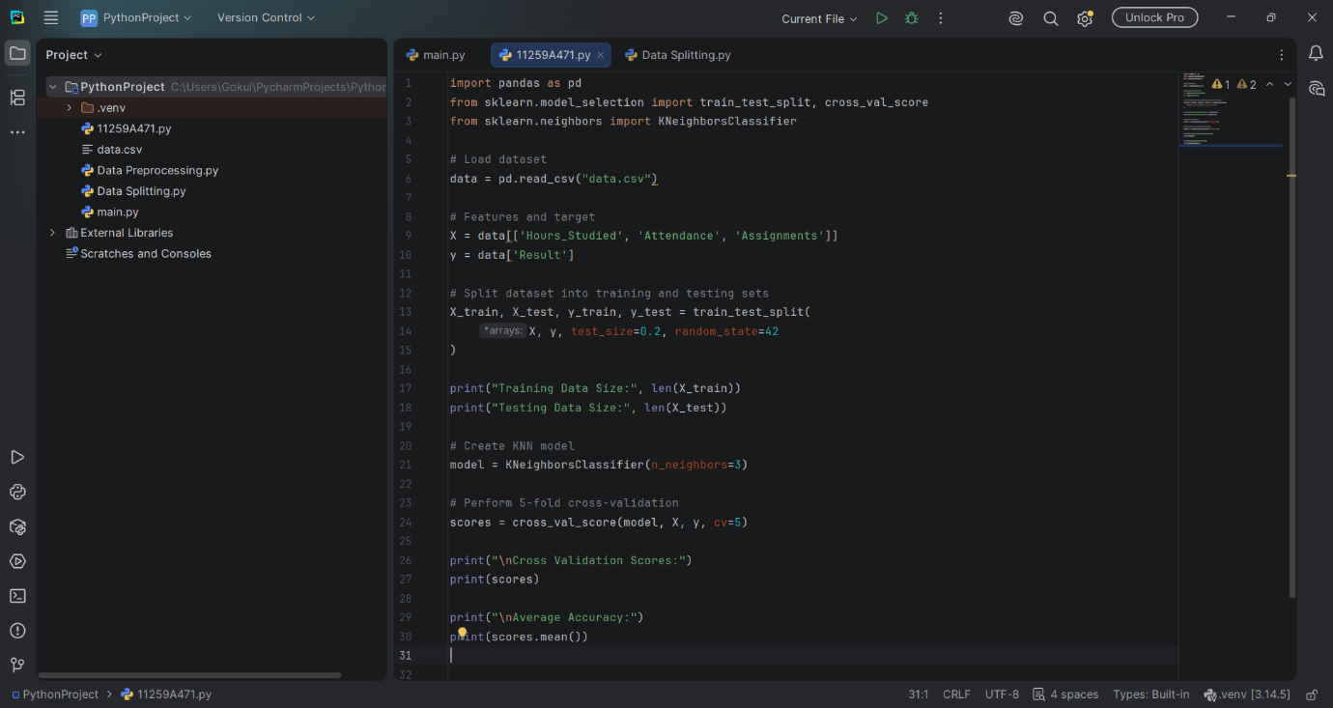

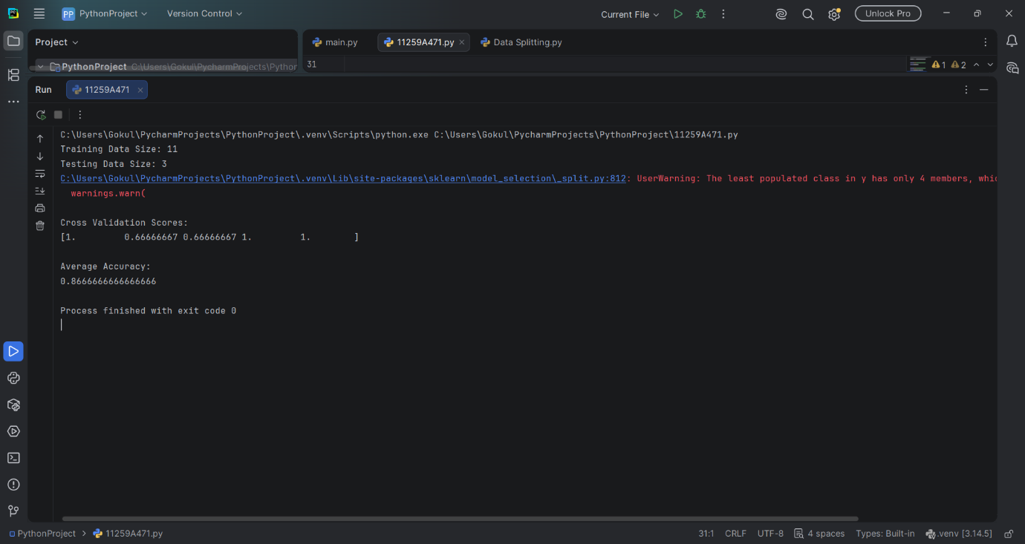

RESULT:
Thus, the dataset was divided into training and testing sets, and cross-validation was performed to evaluate the performance and reliability of the machine learning model.

